Demonstrated that you can read and write the promoted database in the standby region
DATABASE|UDACITY1|AFTER PROMOTION
RECONNECTING AFTER PROMOTING
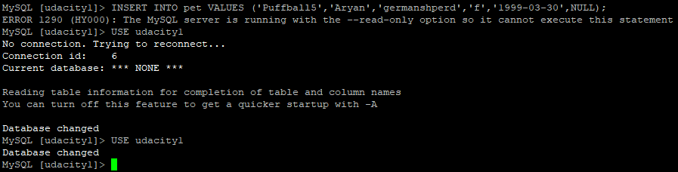
ABLE TO READ FROM DB
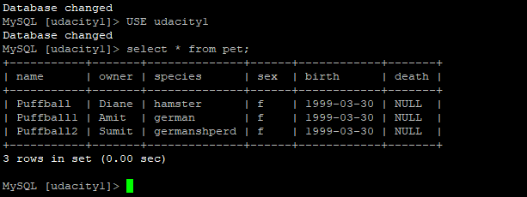

ABLE TO WRITE ROWS TO THE TABLES IN DATABASE AFTER PROMOTING
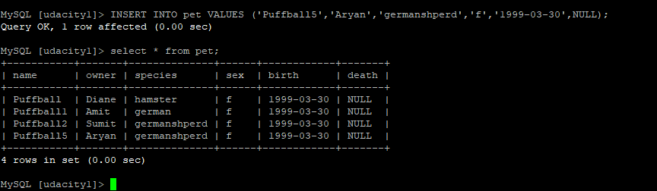

SCREENSHOT OF THE CONFIGRATION AFTER PROMOTING THE REPLICA

